Patch Requests

To obtain a Truth or Consequences, New Mexico Police patch send your request and $10.00 with a self-addressed envelope with postage to:
Truth or Consequences Police Department
Attn: Administrative Aide (Patch Request)
507 McAdoo Street
Truth or Consequences, NM 87901
Patch Collectors: Due to the large number of requests received from around the world, the Truth or Consequences Police Department cannot provide and/or donate patches upon request. Patches may be purchased with a cashier’s check or money-order made payable to: City of Truth or Consequences.
Please do not send patches for exchange.
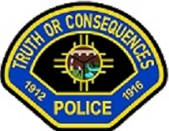

The town's name was changed from "Hot Springs" to "Truth or Consequences" on March 31, 1950, after Ralph Edwards, the host of the popular game show "Truth or Consequences," called for any town in America to change its name to Truth or Consequences --in celebration of the show's ten year anniversary. In the deal was that any city that changes its name would result in the show filming its first live show in that city. Edwards visited the town during the first weekend of May for the next 50 years.

